Look at the table below. You can see that the electoral system used in Britain doesn't seem to add up. In the 2001 election, the Labour party received only four out of every ten votes, but it "won more than six out of every ten seats in the House of Commons. It won two-and-a-half times as many seats as the Conservative party, even though it received less than one-and-a-half times as many votes. The Liberal Democrat party did very badly out of the system. It got almost a fifth of the vote, but won only one in thirteen of the seats in the Commons. And yet it was much luckier than it had been in the past. The arithmetical absurdity of the system becomes clear when we compare the fortunes of the Liberal Democrats this time with their fortunes in the 1992 election. On that occasion, it got the same proportion of the total vote but fewer than half the number of seats. What's going on? As is often the case with British institutions, the apparently illogical figures are the result of history.
The system
Unlike in any other country in the world, the system of political representation that is used in Britain evolved before the coming of democracy. It also evolved before national issues became more important to people than local ones. In theory, the House of Commons is simply a gathering of people who each represent a particular place in the kingdom. Originally, it was not the concern of anybody in government as to how each representative was chosen. That was a matter for each town or county to decide for itself. Not until the nineteenth century were laws passed about how elections were to be conducted (> The ution of the electoral system).
> BRITISH GENERAL ELECTION RESULTS 2001
 | Labour | Conservative | Liberal Democrat | All other parties
Votes MPs Votes per MP | 10, 740 ,648 (41%) 413 (63%) 26,oo6 | 8 .357 ,292 (32%) l66 (25%)  50,345 | 4 ,816 ,137 (i8%)  5.2 (8%)  92 ,618 | 2 ,454 ,453 (9%) 28 (4%)  87 .659

99

This system was in place before the development of modem political parties (see chapter 6). These days, of course, nearly everybody votes for a candidate because he or she belongs to a particular party. But the tradition remains that an MP is first and foremost a representative of a particular locality. The result of this tradition is that the electoral system is remarkably simple. It works like this. The country is divided into a number of areas of roughly equal population (about 90,000), known as constituencies. Anybody who wants to be an MP must declare himself or herself as a candidate in one of these constituencies. On polling day (the day of the election), voters go to polling stations and are each given a single piece of paper (the ballot paper) with the names of the candidates for that constituency (only) on it. Each voter then puts a cross next to the name of one candidate. After the polls have closed, the ballot papers are counted. The candidate with the largest number of crosses next to his or her name is the winner and becomes the MP for the constituency.
And that's the end of it. There is no preferential voting (if a voter chooses more than one candidate, that ballot paper is 'spoiled' and is not counted); there is no counting of the proportion of votes for each party (all votes cast for losing candidates are simply ignored);
there is no extra allocation of seats in Parliament according to party strengths. At the 2001 election, there were 659 constituencies and 659 MPs were elected. It was called a general election, and of course control of the government depended on it, but in formal terms it was just 659 separate elections going on at the same time.
Here are the results from two constituencies in 2001.
 | Taunton | Votes | Rochdale | Votes
Conservative Liberal Democrat Labour | Adrian Flook Jackie Ballard Andrew Govier | 23,033 22,798 8,254 | Elaina Cohen Paul Rowen Loran Fitzsimons | 5,274 13,751 19,406

>The evolution of the electoral system
1832
The Great Reform Bill is passed.
Very small boroughs, where electors can easily be persuaded who to vote for, are abolished.
Seats are given to large new towns such as Birmingham and Manchester, which have until now been unrepresented in Parliament.
The franchise (the right to vote) is made uniform throughout the country, although differences between rural and urban areas remain. It depends on the value of property owned. About 5% of the adult population now has the right to vote in elections.
1867
The franchise is extended to include most of the male workers in towns.
1872
The secret ballot is introduced. (Until now, voting has been by a show of hands.)

If we add the votes received for each party in these two constituencies together, we find that the Liberal Democrats got more votes than Conservative or Labour. And yet, these two parties each won a seat while the Liberal Democrats did not. This is because they were not first in either constituency. It is coming first that matters. In fact, the system is known as the 'first-past-the-post' system (an allusion to horse-racing).
Formal arrangements
hi practice, it is the government which decides when to hold an election. The law says that an election has to take place at least every five years. However, the interval between elections is usually a bit shorter than this. A party in power does not normally wait until the last possible moment. For example, the Labour government called the 2001 election after only four years. When a party
1884
The franchise is extended to include male rural labourers.
1918
Women over the age of thirty are given the right to vote.
1928
Women are given the franchise on the same basis as men. All adults over
twenty-one now have the right to vote.
1969
The minimum voting age is lowered to eighteen, and candidates are now allowed to enter a 'political description' of themselves next to their names on the ballot paper. Until now, the only information about a candidate that has been allowed on the ballot paper was his or her address.

100 10 Elections

> Crazy candidates
You don't have to belong to an important party to be a candidate. You don't even have to live in the constituency. All you need is £5oo. Look at this list of candidates from the 1992 election for the constituency of Huntingdon.
Miss Deborah Birkhead Green Lord Buckethead Gremloids Charles Cockell Forward to Mars Party Andrew Duff Liberal Democrat Michael Flanagan Conservative
Thatcherite
John Major Conservative Hugh Seckleman Labour David Shepheard Naturol Law Party Lord David Sutch Official Monster
Raving Loony Party Paul Wiggin Liberol
Seven of these ten candidates did not get their money back. But there are always some people who are willing to be candidates even when they know they have no chance of winning. Sometimes they are people fighting for a single cause that they feel very strongly about. Sometimes they are people who just like to be candidates for a joke. In this case they tend to be candidates in constituencies where they will get a lot of publicity. Huntingdon is where the Prime Minister at that time, John Major, was a candidate, so it was a natural choice.
The most famous of these ‘silly’ candidates was 'Lord' David Sutch. He was a candidate in the same constituency as the Prime Minister in every election from 1966 to 1997. The intention of the £ 500 deposit is to discourage joke candidates such as 'Lord' Sutch, but they certainly add colour and amusement to the occasion.
has a very small majority in the House of Commons, or no majority at all, the interval can be much shorter.
After the date of an election has been fixed, people who want to be candidates in a constituency have to deposit £5-00 with the Returning Officer (the person responsible for the conduct of the election in each constituency). They get this money back if they get S°/o of the votes or more. The local associations of the major parties will have already chosen their candidates (see chapter 6) and will pay the deposits for them. However, it is not necessary to belong to a party to be a candidate. It is a curious feature of the system that, legally speaking, parties do not exist. That is to say, there is no written law which tries to define them or regulate them. The law allows candidates, if they wish, to include a short 'political description' of themselves on the ballot paper. In practice, of course, most of these descriptions simply state 'Conservative', 'Labour’ or 'Liberal Democrat'. But they can actually say anything that a candidate wants them to say (> Crazy candidates).
To be eligible to vote, a person must be at least eighteen years old and be on the electoral register. This is compiled every year for each constituency separately. People who have moved house and have not had time to get their names on the electoral register of their new constituency can arrange to vote by post. Nobody, however, is obliged to vote.
The campaign
British elections are comparatively quiet affairs. There is no tradition of large rallies or parades as there is in the USA. However, because of the intense coverage by the media, it would be very difficult to be in Britain at the time of a campaign and not realize that an election was about to take place.
The campaign reflects the contrast between the formal arrangements and the political reality. Formally, a different campaign takes place in each constituency. Local newspapers give coverage to the candidates; the candidates themselves hold meetings; party supporters stick up posters in their windows; local party workers spend their time canvassing (> Canvassing). The amount of money that candidates are allowed to spend on their campaigns is strictly limited. They have to submit detailed accounts of their expenses for inspection. Any attempt to influence voters improperly is outlawed.
But the reality is that all these activities and regulations do not usually make much difference. Nearly everybody votes for a candidate on the basis of the party which he or she represents, not because of his or her individual qualities or political opinions. Few people attend candidates' meetings; most people do not read local newspapers. In any case, the size of constituencies means that candidates cannot meet most voters, however energetically they go from door to door.

Polling day 101

It is at a national level that the real campaign takes place. The parties spend millions of pounds advertising on hoardings and in newspapers. By agreement, they do not buy time on television as they do in the USA. Instead, they are each given a number of strictly timed 'party election broadcasts'. Each party also holds a daily televised news conference. All of this puts the emphasis on the national party personalities rather than on local candidates. Only in the 'marginals' - constituencies where only a small shift in voting behaviour from last time would change the result - might the qualities of an individual candidate, possibly, affect the outcome.
Polling day
General elections always take place on a Thursday. They are not public holidays. People have to work in the normal way, so polling stations are open from seven in the morning till ten at night to give everybody the opportunity to vote. The only people who get a holiday are schoolchildren whose schools are being used as polling stations.
Each voter has to vote at a particular polling station. After being ticked off on the electoral register, the voter is given a ballot paper. Elections on the British mainland are always very fairly conducted. Northern Ireland, however, is a rather different story. There, the political tensions of so many years have had a negative effect on democratic procedures. Matters have improved since the i 96os, but the traditional, albeit joking, slogan in Ulster on polling day is 'vote early and vote often' - that is, try to vote as many times as you can by impersonating other people.
After the polls close, the marked ballot papers are taken to a central place in the constituency and counted. The Returning Officer then makes a public announcement of the votes cast for each candidate and declares the winner to be the MP for the constituency. This declaration is one of the few occasions during the election process when shouting and cheering may be heard.
> Canvassing
This is the activity that occupies most of the time of local party workers during an election campaign. Canvassers go from door to door, calling on as many houses as possible and asking people how they intend to vote. They rarely make any attempt to change people's minds, but if a voter is identified as 'undecided', the party candidate might later attempt to pay a visit.
The main purpose of canvassing seems to be so that, on election day, transport can be offered, if needed, to those who claim to be supporters. (This is the only form of material help that parties are allowed to offer voters.) It also allows party workers to estimate how well they are doing on election day. They stand outside polling stations and record whether their supporters have voted. If it looks as if these people are not going to bother to vote, party workers might call on them to remind them to do so. Canvassing is an awful lot of work for very little benefit. It is a kind of election ritual.

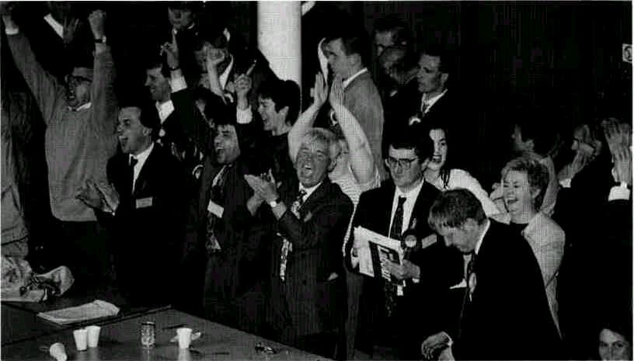
An election result being declared

102 10 Elections

> The great television election show!
British people are generally not very enthusiastic about politics. But that does not stop them enjoying a good, political fight. Notice the images of sport and of generals planning a military campaign in this extract from the Radio Times from just before the 1992 general election.
What a night it's going to be! As in all the best horseraces there is no clear favourite. Not since 1974 have the two main parties been so closely matched. We may even keep you up all night without being able to tell you who's won...
On BBCI's 'Election 92', I'll have a whole array of electronic wizardry - including our Battleground — to help explain and illustrate what is shaping the new Parliament.
Over 30 million people will have voted by i o p.m. on the Thursday, but the decisive verdict will be pronounced by the five million people who vote in the marginal seats - and these are the ones we feature in our Battle-ground.
Labour's aim is to colour the seats on the Battleground red. The Conservatives' task is to keep them blue...
So sit back in your armchair and enjoy the excitement.
Radio Times, April 1992
Election night
The period after voting has become a television extravaganza. Both BBC and ITV start their programmes as soon as voting finishes. With millions watching, they continue right through the night. Certain features of these 'election specials', such as the 'swmgometer' have entered popular folklore (> The Swingometer).
The first excitement of the night is the race to declare. It is a matter of local pride for some constituencies to be the first to announce their result. Doing so will guarantee that the cameras will be there to witness the event. If the count has gone smoothly, this usually occurs at just after 11.00 p.m. By midnight, after only a handful of results have been declared, experts (with the help of computers) will be making predictions about the composition of the newly elected House of Commons. Psephology (the study of voting habits) has become very sophisticated in Britain so that, although the experts never get it exactly right, they can get pretty close.
By two in the morning at least half of the constituencies will have declared their results and, unless the election is a very close one (as, for example, in 1974 and 1992), the experts on the television will now be able to predict with confidence which party will have a majority in the House of Commons, and therefore which party leader is going to be the Prime Minister.
Some constituencies, however, are not able to declare their results until well into Friday afternoon. This is either because they are very rural (mostly in Scotland or Northern Ireland), and so it takes a long time to bring all the ballot papers together, or because the race has been so close that one or more 'recounts' have been necessary. The phenomenon of recounts is a clear demonstration of the ironies of the British system. In most constituencies it would not make any difference to the result if several thousand ballot papers were lost. But in a few, the result depends on a handful of votes. In these cases, candidates are entitled to demand as many recounts as they want until the result is beyond doubt. The record number of recounts is seven (and the record margin of victory is just one vote!).
Recent results and the future
Since the middle of the twentieth century, the contest to form the government has effectively been a straight fight between the Labour and Conservative parties. As a general rule, the north of England and most of the inner areas of English cities return Labour MPs to Westminster, while the south of England and most areas outside the inner cities have a Conservative MR Which of these two parties forms the government depends on which one does better in the suburbs and large towns of England.
Scotland used to be good territory for the Conservatives. This changed, however, during the 1980s and the vast majority of MPs from there now represent Labour. Wales has always returned mostly

Recent results and the future 103
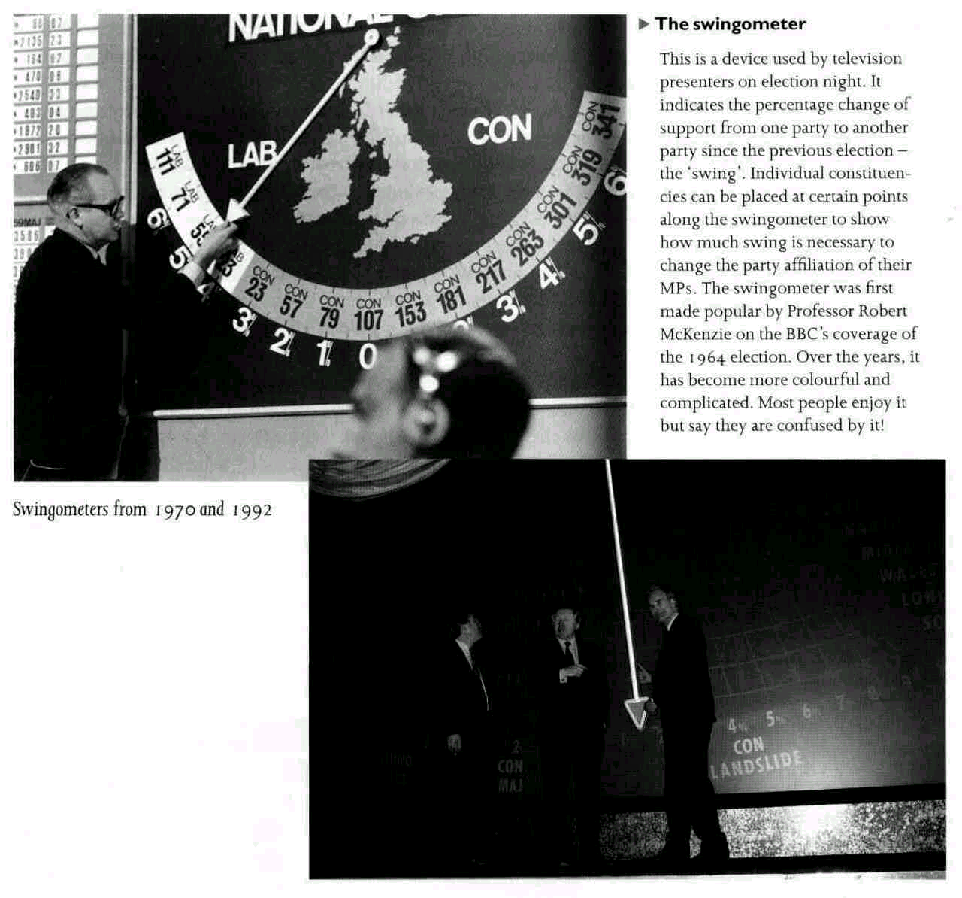
Labour MPs. Since the 1970s, the respective nationalist parties in both countries (see chapter 6) have regularly won a few seats in Parliament.
Traditionally, the Liberal party was also relatively strong in Scotland and Wales (and was sometimes called the party of the 'Celtic fringe'). Its modern successor, the Liberal Democrat party (see chapter 6), is not so geographically restricted and has managed to win some seats all over Britain, with a concentration in the south-west of England.
Northern Ireland always has about the same proportion of Protestant Unionist MPs and Catholic Nationalist MPs (since the 1970 s, about two-thirds the former, the third the latter). The only element of uncertainty is how many seats the more extremist (as opposed to the more moderate) parties will win on either side of this invariant political divide (see chapter 12).
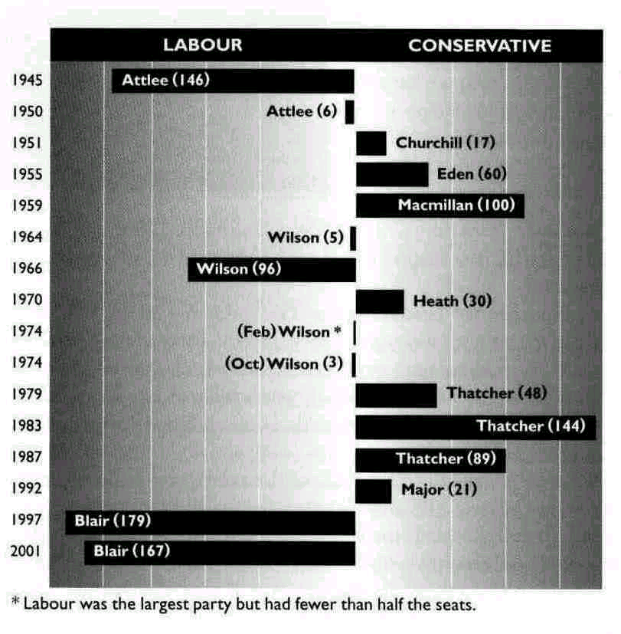
104 10 Elections
> By-elections
Whenever a sitting MP can no longer fulfil his or her duties, there has to be a special new election in the constituency which he or she represents. (There is no system of ready substitutes.) These are called by-elections and can take place at any time. They do not affect who runs the government, but they are watched closely by the media and the parties as indicators of the current level of popularity (or unpopularity) of the government.
A by-election provides the parties with an opportunity to find a seat in Parliament for one of their important people. If a sitting MP dies, the opportunity presents itself;
if not, an MP of the same party must be persuaded to resign.
The way an MP resigns offers a fascinating example of the importance attached to tradition. It is considered wrong for an MP simply to resign; MPs represent their constituents and have no right to deprive them of this representation. So the MP who wishes to resign applies for the post of'Steward of the Chiltern Hundreds'.This is a job with no duties and no salary. Technically, however, it is 'an office of profit under the Crown' (i.e. a job given by the monarch with rewards attached to it). According to ancient practice, a person cannot be both an MP and hold a post of this nature at the same time because Parliament must be independent of the monarch. (This is why high ranking civil servants and army officers are not allowed to be MPs.) As a result, the holder of this ancient post is automatically disqualified from the House of Commons and the by-election can go ahead!
In the thirteen elections from 1945 to 1987, the Conservatives were generally more successful than Labour. (> Party performance in general elections since 1945). Although Labour achieved a majority on five occasions, on only two of these was the majority comfortable. On the other three occasions it was so small that it was in constant danger of disappearing as a result of by-election defeats (> Byelections) . In the same period, the Conservatives won a majority seven times, nearly always comfortably.
Then, in the 1992 election, the Conservatives won for the fourth time in a row - the first time this had been achieved for more than 160 years. Moreover, they achieved it in the middle of an economic recession. This made many people wonder whether Labour could ever win again. It looked as if the swingometer's pendulum had stuck on the right. Labour's share of the total vote had generally decreased in the previous four decades while support for the third party had grown since the early 1970s. Many sociologists believed this trend to be inevitable because Britain had developed a middle-class majority (as opposed to its former working-class majority). Many political observers were worried about this situation. It is considered to be basic to the British system of democracy that power should change hands occasionally. There was much talk about a possible reorganization of
Size of overall majority in the House of Commons (with name of leader of winning party)
Recent results and the future 105
British politics, for example a change to a European-style system of proportional representation (so that Labour could at least share in a coalition government), or a formal union between Labour and the Liberal Democrats (so that together they could defeat the Conservatives).
However, in 1997 the picture changed dramatically. Labour won the largest majority in the House of Commons achieved by any party for 73 years and the Conservative share of the total vote was their lowest in 165 years. What happened? The answer seems to be that voting habits in Britain, reflecting the weakening of the class system, are no longer tribal. There was a time when the Labour party was regarded as the political arm of the trade unions, representing the working class of the country. Most working-class people voted Labour all their lives and nearly all middle-class people voted Conservative all their lives. The winning party at an election was the one who managed to get the support of the small number of 'floating voters'. But Labour has now got rid of its trade-union image. It is capable of winning as many middle-class votes as the Conservatives, so that the middle-class majority in the population, as identified by sociologists (see above), does not automatically mean a Conservative majority in the House of Commons.

QUESTIONS
1 The British electoral system is said to discriminate against smaller parties. But look at the table at the beginning of this chapter again. How can it be that the very small parties had much better luck at winning parliamentary seats than the (comparatively large) Liberal Democrats?
2 In what ways is political campaigning in your country different from that in Britain as described in this chapter?
3 Is there a similar level of public interest in learning about election results in your country as there is in Britain? Does it seem to reflect the general level of enthusiasm about, and interest in, politics which exist at other times - in Britain and in your own country?

4 Britain has 'single-member constituencies'. This means that one MP alone represents one particular group of voters (everybody in his or her constituency). Is this a good system? Or is it better to have several MPs representing the same area? What are the advantages and disadvantages of the two systems?
5 Do you think that Britain should adopt the electoral system used in your country? Or perhaps you think that your country should adopt the system used in Britain? Or are the two different systems the right ones for the two different countries? Why?

SUGGESTIONS
• If you can get British television or radio, watch or listen in on the night of the next British general election.

