12
International relations

The relationship between any country and the rest of the world can
reveal a great deal about that country.
The end of empire
The map below shows the British empire in i 91 9, at the time of its greatest extent. By this time, however, it was already becoming less of an empire and more of a confederation. At the same international conference at which Britain acquired new possessions (formerly German) under the Treaty of Versailles, Australia, Canada, New Zealand and South Africa were all represented separately from Britain.
The real dismantling of the empire took place in the twenty-five years following the Second World War and with the loss of empire went a loss of power and status. These days, Britain's armed forces can no longer act unilaterally, without reference to the international community. Two events illustrate this. First, Suez. In 1956, Egypt, without prior agreement, took over the Suez canal from the international company owned by Britain and France. British and French
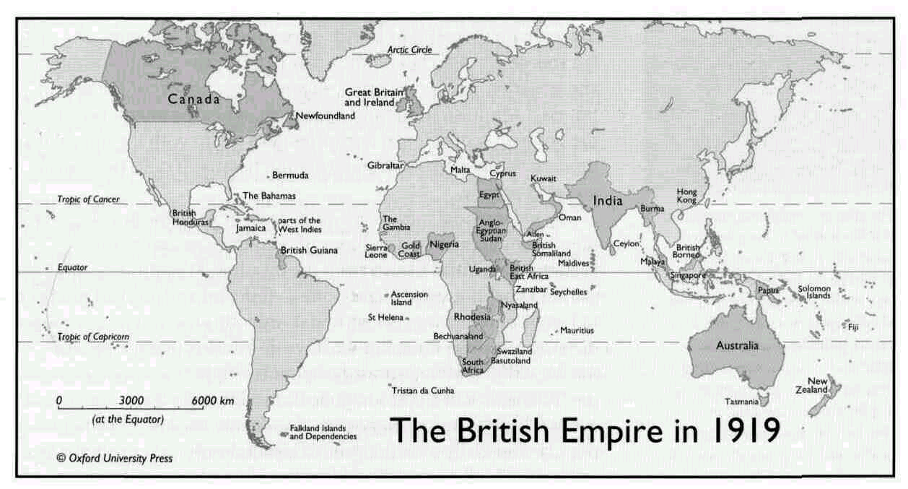

114 12 International relations

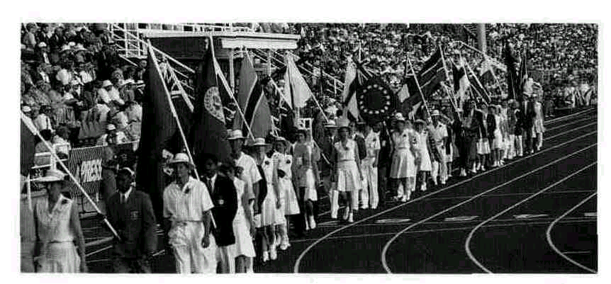
The opening ceremony of the Commonwealth Games in 1994. This athletics contest is held every four years.

^The Commonwealth
The dismantling of the British empire took place comparatively peacefully, so that good relations between Britain and the newly independent countries were established. As a result, and with the encouragement of Queen Elizabeth II, an international organization called the Commonwealth, composed of the countries that used to be part of the empire, has continued to hold annual meetings. Some countries in the Commonwealth have even kept the British monarch as head of state.
There are no formal economic or political advantages involved in belonging to the Commonwealth, but it has helped to keep cultural contacts alive, and does at least mean that every year the leaders of a sixth of the world's population sit down and talk together. Until quite recently it did have economic importance, with special trading agreements between members. But since Britain became a full member of the EEC, all but a few of these agreements have gradually been discontinued.
military action to stop this was a diplomatic disaster. The USA did not support them and their troops were forced to withdraw. Second, Cyprus. When this country left the British empire, Britain became one of the guarantors of its independence from any other country. However, when Turkey invaded the island in 1974, British military activity was restricted to airhfting the personnel of its military base there to safety.
After the Second World War and throughout the 1950s, it was understood that a conference of the world's great powers involved the USA, the Soviet Union and Britain. However, in 1962, the Cuban missile crisis, one of the greatest threats to global peace since the war, was resolved without reference to Britain. By the 1970s it was generally accepted that a 'superpower' conference involved only the USA and the Soviet Union.
Despite Britain's loss of power and status on the world stage, some small remnants of the empire remain, Whatever their racial origins, the inhabitants of Gibraltar, St Helena, the Ascension Islands, the Falklands/Malvinas and Belize have all wished to continue with the imperial arrangement (they are afraid of being swallowed up by their nearest neighbours). For British governments, on the one hand this is a source of pride, but on the other hand it causes embarrassment and irritation: pride, because it suggests how beneficial the British imperial administration must have been; embarrassment, because the possession of colonial territories does not fit with the image of a modern democratic state; and irritation because it costs the British taxpayer money.
The old imperial spirit is not quite dead. In 1982 the British government spent hundreds of millions of pounds to recapture the Falklands/Malvinas Islands from the invading Argentinians. We cannot know if it would have done so if the inhabitants had not been in favour of remaining British and if Argentina had not had a military dictatorship at the time. But what we do know is that the government's action received enormous popular support at home. Before the 'Falklands War', opinion polls showed that the government was extremely unpopular; afterwards, it suddenly became extremely popular and easily won the general election early in the following year.

The armed forces 115

The armed forces
The loyalty of the leaders of the British armed forces to the government has not been in doubt since the Civil War (with the possible exception of a few years at the beginning of the twentieth century -see chapter 2). In addition, and with the exception of Northern Ireland, the army has only rarely been used to keep order within Great Britain in the last 100 years.
'National Service' (a period of compulsory military service for all men) was abolished in 1957. It had never been very popular. It was contrary to the traditional view that Britain should not have a large standing army in peacetime. Moreover, the end of empire, together with the increasing mechanization of the military, meant that it was more important to have small, professional forces staffed by specialists. The most obviously specialist area of the modern military is nuclear weapons. Since the 1950s, the Campaign for Nuclear Disarmament (CND) has argued, on both moral and economic grounds, that Britain should cease to be a nuclear power. At certain periods the CND has had a lot of popular support (> Greenhorn Common). However, this support has not been consistent. Britain still has a nuclear force, although it is tiny compared to that of the USA.
The end of the 'Cold War' between the west and the Soviet Union at the end of 198os caused the British government to look for the 'peace dividend' and to reduce further the size of the armed forces. This caused protest from politicians and military professionals who were afraid that Britain would not be able to meet its 'commitments' in the world. These commitments, of course, are now mostly on behalf of the United Nations or the European Union. There is still a feeling in Britain that the country should be able to make significant contributions to international peacekeeping efforts. The reduction also caused bad feeling within sections of the armed forces themselves. Its three branches (the Army, the Royal Navy and the Royal Air Force) have distinct traditions and histories that it was felt were being threatened. The army in particular was unhappy when several famous old regiments, each with their own distinct traditions, were forced to merge with others. At one time, a number of upper-middle class families maintained a tradition down the generations of belonging to a particular regiment. Fewer and fewer such families exist today. However, a career in the armed forces is still highly respectable. In fact, Britain's armed forces are one of the few institutions that its people admit to being proud of.
Transatlantic relations
Since the Second World War, British governments have often referred to the 'special relationship* which exists between Britain and the USA. There have been occasional low points, such as Suez (see above) and when the USA invaded the Caribbean island of Grenada (a member of the British Commonwealth). But generally speaking it
> The senior service
This is a phrase sometimes used to describe the Royal Navy. It was the first of the three armed forces to be established. Traditionally, it traces its history right back to King Alfred (see chapter 2).
> Greenham Common
Greenham Common is the Royal Air Force base in Berkshire which became ihe focus for anti-nuclear campaigners (mainly women) in the 1980s. American Cruise nuclear missiles were based there from 1983 to 1991.
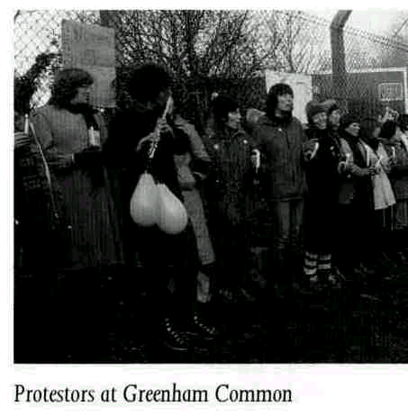

116 12 International relations

> Is Britain really part of Europe?
The government says it is, but look at this report from The Sunday Times of 18 April 1993.
Britain bans EC medals
British members of the European Community monitoring mission in former Yugoslavia have been banned from a formal presentation of medals struck by the EC to honour their bravery.
The British monitors have been told that they may only receive the medals privately and keep them as momentoes. They must never wear them on their uniforms because of government rules against the acceptance of decorations from 'foreign powers'.
" ... Many are angered by the decision to count the EC as a foreign power.
has persisted. It survived the Falklands War, when the USA offered Britain important material help, but little public support, and regained its strength in 1991 during the Gulf War against Iraq, when Britain gave more active material support to the Americans than any other European country.
Public feeling about the relationship is ambiguous. On the one hand, it is reassuring to be so diplomatically close to the most powerful nation in the world, and the shared language gives people some sense of brotherhood with Americans. On the other hand, there is mild bitterness about the sheer power of the USA. There is no distrust, but remarks are often made about Britain being nothing more than the fifty-first state of the USA. Similarly, while some older people remember with gratitude the Americans who came to their aid in two world wars, others resent the fact that it took them so long to get involved!
In any case, the special relationship has inevitably declined in significance since Britain joined the European Community. In the world trade negotiations of the early 1990s, there was nothing special about Britain's position with regard to the USA - it was just part of the European trading bloc. The opening of the Channel tunnel in 1994 has emphasized that Britain's links are now mainly with Europe. Tourist statistics also point this way. In 1993, for the first time, it was not American visitors who arrived in the greatest numbers, it was the French, and there were almost as many German visitors as Americans. The majority of visitors to Britain are now from Europe.
The sovereignty of the union: Europe
When the European Coal and Steel Community was formed in 1951, Britain thought it was an excellent idea, but nothing to do with Britain! Long years of an empire based on sea power meant that the traditional attitude to Europe had been to encourage stability there, to discourage any expansionist powers there, but otherwise to leave it well alone.
As the empire disappeared, and the role of'the world's policeman' was taken over by the USA, the British government decided to ask for membership of the newly-formed European Communities. It took more than ten years for this to be achieved (in 1973). From the very start, the British attitude to membership has been ambiguous. On the one hand, it is seen as an economic necessity and a political advantage (increasing Britain's status as a regional power). The referendum on continued membership in 1975 (the first in British history) produced a two-to-one majority in favour. On the other hand, acceptance does not mean enthusiasm. The underlying attitude — that Britain is somehow special — has not really changed and there are fears that Britain is gradually giving up its autonomy. Changes in European

Europe 117,
> The British sausage
Below is an extract from the script of the BBC satirical comedy Yes, Prime Minister. It is part of a speech made by James Hacker MP, in which he expresses anti-European sentiments. It is fiction, of course, but it does capture part of the British attitude to Europe. In the story, Hacker's speech makes him so popular that he
becomes the new Prime Minister!
Notice how, in the speech, sovereignty is not connected with matters of conventional political power, but rather with matters of everyday life and habits. (For the references to pints, yards, tanners etc, see chapter 5.)
I'm a good European. I believe in Europe. I believe in the European ideal! Never again shall we repeat the bloodshed of two World Wars. Europe is here to stay.
But this does not mean that we have to bow the knee to every directive from every bureaucratic Bonaparte in Brussels. We are a sovereign nation still and proud of it. [applause]
We have made enough concessions to the European Commissar for ,;
agriculture. We have swallowed the wine lake, we have swallowed the butter mountain, we have watched our French 'friends' beating up British lorry drivers carrying good British lamb to the French public. We have bowed and scraped, tugged our forelocks and turned the other cheek. But I say enough is enough! [prolonged applause]
The Europeans have gone too far. They are now threatening the British sausage. They want to standardize it — by which they mean they'll force the British people to eat salami and bratwurst and other garlic-ridden greasy foods that are totally alien to the British way of life. [cries of 'hear hear', 'right on' and 'you tell 'em, Jim'].
Do you want to eat salami for breakfast with your egg and bacon? I don't. And I won't! [massive applause]
They've turned our pints into litres and our yards into metres, we gave up the tanner and the threepenny bit, the two bob and the half-crown. But they cannot and will not destroy the British sausage! [applause and cheers]. Not while I'm here. [tumultuous applause].
In the words of Martin Luther: Here I stand, I can do no other. [Hacker sits down. Shot of large crowd rising to its feet in appreciation]
domestic policy, social policy or sovereignty arrangements tend to be seen in Britain as a threat (> The British sausage). Throughout the 19805 and 1990S it has been Britain more than any other member of the European Union (as it is now called) which has slowed down progress towards further European unity. Meanwhile, there is a certain amount of popular distrust of the Brussels bureaucracy.
This ambiguous attitude can partly be explained by the fact that views about Britain's position in Europe cut across political party lines. There are people both for and against closer ties with Europe in both the main parties. As a result, 'Europe' has not been promoted as a subject for debate to the electorate. Neither party wishes to raise the subject at election time because to do so would expose divisions within that party (a sure vote-loser).
> Up yours, Delors
This was the front page headline of
the Sun, Britain's most popular newspaper, on i November 1990. It gives voice, in a vulgar manner, to British dislike of the Brussels bureaucracy. Jacques Delors was president of the European Commission at the time. The expression 'up yours' is the spoken equivalent of a rude, two-fingered gesture. Notice how the full effect of the phrase is only possible if the French name 'Delors' is pronounced in an English way, rhyming the second syllable of 'Delors' with 'yours'. Even serious, so-called 'quality' British newspapers can sometimes get rather hysterical about the power of Brussels. When, in 1991, the British government refused to agree the social chapter in the Maastricht Treaty, The Sunday Times published an article warning that the EU might still try to impose the chapter on Britain. The headline described this possibility as 'Ambush'.
> The European history book
Sir Francis Drake is a well-known English historical character. In 15-88 he helped to defeat the Spanish Armada which was trying to invade England. Or did he? Historians know that there was a terrible storm which broke up the Spanish fleet.
In 1992 an EC history 'textbook' for secondary schools, written by a committee of historians from every member state, was published. The first version of the book decided that it was the weather which caused the failure of the Spanish invasion, the second that it was Drake. The book was published at the same time in Dutch, French, German, Greek, Italian and Portuguese. But, strangely enough, no publisher for either a British or a Spanish edition could be found.

118 12 International relations

> Scotland
This was the front page of the Sun's
Scottish edition on 2 3 January 1992, when it decided to support the campaign for Scottish independence (see chapter18). The design shows the cross of St Andrew, the national flag of Scotland.
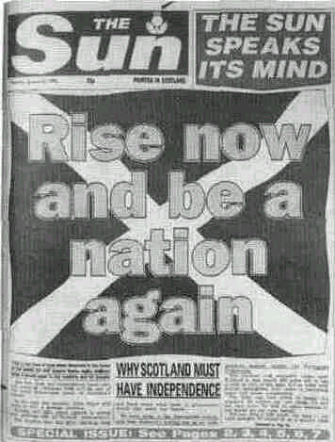
> Ulster
Ulster is the name often used to describe the part of Ireland which is in the UK. It is the name of one of the four ancient kingdoms of Ireland. (The others are Leinster, Munster and Connaught). In fact, the British province does not embrace all of Ulster's nine counties; three of its counties belong to the republic. The name 'Northern Ireland' is not used by some nationalists; they think it gives validity to an entity which they do not recognize. One of the alternative names they use is 'the six counties'
The sovereignty of the union: Scotland and Wales
There is another reason for a distrust of greater European cohesion among politicians at Westminster. It is feared that this may not just be a matter of giving extra power to Brussels. It may also be a matter of giving extra powers to the regions of Britain, especially its different nations.
Until recently most Scottish people, although they insisted on many differences between themselves and the English, were happy to be part of the UK. But there has always been some resentment in Scotland about the way that it is treated by the central government in London. In the 1980s and early 1990s this resentment increased because of the continuation in power of the Conservative party, for which only around a quarter of the Scottish electorate had voted. Opinion polls consistently showed that between half and three-quarters of the Scottish population wanted either 'home rule' (internal self-government) .within the UK or complete independence.
The realization that, in the EU, home rule, or even independence, need not mean isolation has caused the Scottish attitude to Europe to change. Originally, Scotland was just as cautious as England. But now the Scottish, as a group, have become the most enthusiastic Europeans in the UK. Scotland now has its own parliament which controls its internal affairs and even has the power to vary slightly the levels of income tax imposed by the UK government. It is not clear whether complete independence will eventually follow, but this is the policy of the Scottish National Party (SNP), which is well represented in the new parliament.
In Wales, the situation is different. The southern part of this nation is thoroughly Anglicized and the country as a whole has been fully incorporated into the English governmental structure for more than 400 years. Nationalism in Wales is felt mostly in the central and northern part of the country, where it tends to express itself not politically, but culturally (see chapter 4). Many people in Wales would like to have greater control over Welsh affairs, but not much more than some people in some regions of England would like the same. Wales also now has its own assembly with responsibility for many internal affairs.
The sovereignty of the union: Northern Ireland
In this section, the word 'Ulster' is used to stand for the British province of Northern Ireland (> Ulster). Politics here is dominated by
the historic animosity between the two communities there (see chapter 4). The Catholic viewpoint is known as 'nationalist' or 'republican' (in support of the idea of a single Irish nation and its republican government); the Protestant viewpoint is known as 'unionist' or 'loyalist' (loyal to the union with Britain).

Northern Ireland 119

A little modern history is necessary to explain the present situation. By the beginning of the twentieth century, when Ireland was still part of the United Kingdom, the vast majority of people in Ireland wanted either home rule or complete independence from Britain. Liberal governments in Britain had accepted this and had attempted at various times to make it a reality. However, the one million Protestants in Ulster were violently opposed to this idea. They did not want to belong to a country dominated by Catholics. They formed less than a quarter of the total population of the country, but in Ulster they were in a 65% majority.
After the First World War the British government partitioned the country between the (mainly Catholic) south and the (mainly Protestant) north, giving each part some control of its internal affairs. But this was no longer enough for the south. There, support for complete independence had grown as a result of the British government's savage repression of the 'Easter Rising' in 1916. War followed. The eventual result was that the south became independent of Britain. Ulster, however, remained within the United Kingdom, with its own Parliament and Prime Minister. The Protestants had always had the economic power in the six counties (> Ulster). Internal self-government allowed them to take all the political power as well. Matters were arranged so that positions of official power were always filled by Protestants.
In the late 1960s a Catholic civil rights movement began. There was violent Protestant reaction and frequent fighting broke out. In 1969 British troops were sent in to keep order. At first they were welcomed, particularly among the Catholics. But troops, inevitably, often act without regard to democratic rights. In the tense atmosphere, the welcome disappeared. Extremist organizations from both communities began committing acts of terrorism, such as shootings and bombings. One of these groups, the Provisional IRA (> Extremist groups), then started a bombing campaign on the British mainland. In response, the British government reluctantly imposed certain measures not normally acceptable in a modern democracy, such as imprisonment without trial and the outlawing of organizations such as the IRA. The application of these measures caused resentment to grow. There was a hardening of attitudes in both communities and support for extremist political parties increased.
There have been many efforts to find a solution to 'the troubles' (as they are known in Ireland). In 1972 the British government decided to rule directly from London. Over the next two decades most of the previous political abuses disappeared, and Catholics now have almost the same political rights as Protestants. In addition, the British and Irish governments have developed good relations and new initiatives are presented jointly. The troubles may soon be over. However, despite reforms, inequalities remain. At the time of writing, unemployment among Ulster's Catholics is the highest of
> Extremist groups
The most well-known republican group is the IRA (Irish Republican Army). Seventy years ago this name meant exactly what it says. The IRA was composed of many thousands of people who fought for, and helped to win, Irish independence. Members of the modern IRA are also known as "the Provisionals'. They are a group that split off from the 'official' IRA in the 1960s. They have used a name that once had great appeal to Irish patriotic sentiments. In fact, the IRA has little support in the modem Irish Republic and no connection at all with its government.
The most well-known loyalist groups are the UFF (Ulster Freedom Fighters), theUVF (Ulster Volunteer Force) and the UDA (Ulster Defence Association).
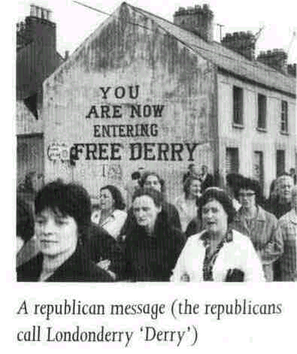
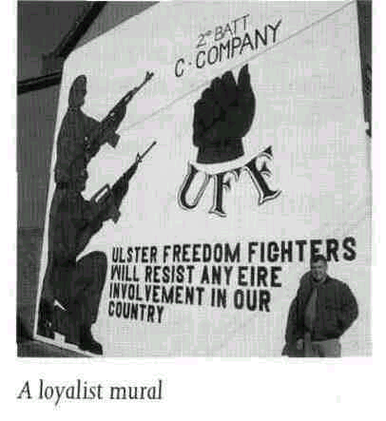

120 12 International relations
any area in the UK, while that among its Protestants is one of the lowest. Members of the police force, the Royal Ulster Constabulary (RUC), are still almost entirely Protestant. Most of all, the basic divisions remain. The Catholics identify with the south. Most of them would like the Irish government in Dublin to have at least a share in the government of Ulster. In 1999 the Republic removed the part of its constitution which included a claim to the six counties. This has calmed Protestant fears about being swallowed up. In return for its gesture, the Republic now has a role to play in a number of all-Ireland bodies which have been set up. Some Protestants still have misgivings about this initiative. It should be noted here that the names 'loyalist' and 'unionist' are somewhat misleading. The Ulster Protestants are distinct from any other section of British society. While it is important to them that they belong to the United Kingdom, it is just as important to them that they do not belong to the Republic of Ireland. From their point of view, and also from the point of view of some Catholics, a place for Ulster in a federated Europe is a possible solution.
In Ulster there is now a general disgust at the activities of extremists, and a strong desire for peace. At the time of writing, nearly all terrorist activities have ceased and a Northern Ireland government which includes representatives of all political views has been set up.

QUESTIONS
1 What indications can you find in this chapter that British people like to think of their country as an important and independent power in the world?
2 Would you say that the British people feel closer to the USA or the European Union? What evidence do you have for your view?
3 The people of Scotland have changed from being 'anti-Europe' to being 'pro-Europe' in the last twenty years of the twentieth century. Why?

4 In 1994, Prime Minister John Major announced that he would like to hold a referendum in Ulster on that area's future constitutional position. Some people said that the referendum should include the whole of Ireland. Which people do you think they were? Why did they say this?
5 Do you think that the present boundaries of the UK should remain as they are or should they change? Do you think they will stay as they are?

SUGGESTIONS
• A Passage to India by E M Forster is set in India at the height of the British Empire and reflects colonial attitudes. (There is also a film of the book.) The Raj Quartet, by Paul Scott (originally four novels, but published in a combined version under this title) is similarly set in India, but in the last years of British rule in the 1940s.

