7
The monarchy

The appearance
The position of the monarch in Britain is a perfect illustration of the contradictory nature of the constitution. From the evidence of written law only, the Queen has almost absolute power, and it all seems very undemocratic. The American constitution talks about 'government of the people for the people by the people'. There is no law in Britain which says anything like that. In fact, there is no legal concept of'the people' at all.
Every autumn, at the state opening of Parliament, Elizabeth II, who became Queen in 1952, makes a speech. In it, she says what 'my government' intends to do in the coming year. And indeed, it is her government, not the people's. As far as the law is concerned, she can choose anybody she likes to run the government for her. There are no restrictions on whom she picks as her Prime Minister. It does not have to be somebody who has been elected. She could choose me;
she could even choose you. The same is true for her choices of people to fill some hundred or so other ministerial positions. And if she gets fed up with her ministers, she can just dismiss them. Officially speaking, they are all 'servants of the Crown' (not servants of anything like 'the country' or 'the people'). She also appears to have great power over Parliament. It is she who summons a Parliament, and she who dissolves it before a general election (see chapter 10). Nothing that Parliament has decided can become law until she has agreed to it.
Similarly, it is the Queen, and not any other figure of authority, who embodies the law in the courts. In the USA, when the police take someone to court to accuse them of a crime, the court records show that 'the people' have accused that person. In other countries it might be 'the state' that makes the accusation. But in Britain it is 'the Crown'. This is because of the legal authority of the monarch. And when an accused person is found guilty of a crime, he or she might be sent to one of' Her Majesty's' prisons.
Other countries have 'citizens'. But in Britain people are legally described as 'subjects' - subjects of Her Majesty the Queen. Moreover, there is a principle of English law that the monarch can do nothing that is legally wrong. In other words. Queen Elizabeth is above the law.
> The house of Windsor
Windsor is the family name of the royal family. The press sometimes refers to its members as 'the Windsors'. Queen Elizabeth is only the fourth monarch with this name. This is not because a 'new' royal family took over the throne of Britain four reigns ago. It is because George V, Elizabeth's grandfather, changed the family name. It was Saxe-Coburg-Gotha, but during the First World War it was thought better for the king not to have a German-sounding name.

78 7 The monarchy

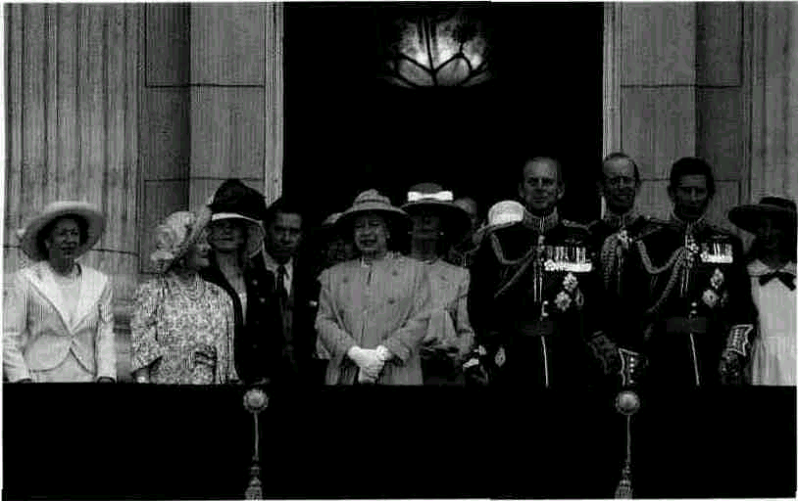
Princess Margaret The Queen Prince Charles
The Queen Mother
Prince Philip

> The royal family
• Queen Elizabeth the Queen Mother
died at the age of 101 in 2002, the year of the present Queen's Golden Jubilee. Her tours of bombed areas of London during the Second World War with her husband, King George VI, made her popular with the British people. She remained the most consistently popular member of the royal family until her death.
• Queen Elizabeth II was born in 1926 and became Queen in 1952 on the death other father, George VI, who had reigned since 1936 (when his elder brother, Edward VIII, gave up the throne). She is one of the longest-reigning monarchs in British history. She is widely respected for the way in which she performs her duties and is generally popular.
• Prince Philip Mountbatten, the Duke of Edinburgh, married the present Queen in 1947. In the 1960s and 1970s, his outspoken opinions on controversial matters were sometimes embarrassing to the royal family.
• Princess Margaret, the Queen's younger sister, died in 2002.
• Prince Charles, the Prince of Wales, was born in 1948. As the eldest son of Queen Elizabeth and Prince Philip, he is heir to the throne. He is concerned about the environment and about living conditions in Britain's cities. He sometimes makes speeches which are critical of aspects of modern life.

• Princess Diana married Prince Charles in 1981. The couple separated in 1992 and later divorced. Princess Diana died as the result of a car accident in 1997. She was a glamorous and popular figure during her lifetime.
• Princess Anne, the Queen's daughter (also known as the Princess Royal), was born in 1950. She separated from her husband after they had one son and one daughter. She married again in 1992. She is widely respected for her charity work, which she does in a spirit of realism.
• Prince Andrew, the Duke of York, was born in 1960 and is the Queen's

second son. He is divorced from his wife, Sarah Ferguson (who is known to the popular press as 'Fergie'). They have two daughters.
• Prince Edward, the Queen's
youngest son, was born in 1964. He is involved in theatrical production. He married Sophie Rhys-Jones in 1999. He and his wife are the Duke and Duchess of Wessex.
• Prince William (born 1982) and Prince Henry (born 1984) are the sons of Charles and Diana. William is next in line to the throne after his father.

The reality
In practice, of course, the reality is very different. In fact, the Queen cannot choose anyone she likes to be Prime Minister. She has to choose someone who has the support of the majority of MPs in the House of Commons (the elected chamber of the two Houses of Parliament). This is because the law says that 'her' government can only collect taxes with the agreement of the Commons, so if she did not choose such a person, the government would stop functioning. In practice the person she chooses is the leader of the strongest party in the House of Commons. Similarly, it is really the Prime Minister who decides who the other government ministers are going to be (although officially the Prime Minister simply 'advises' the monarch who to choose).

The role of the monarch 7 9

It is the same story with Parliament. Again, the Prime Minister will talk about 'requesting' a dissolution of Parliament when he or she wants to hold an election, but it would normally be impossible for the monarch to refuse this 'request'. Similarly, while, in theory, the Queen could refuse the royal assent to a bill passed by Parliament -and so stop it becoming law (see chapter 9) - no monarch has actually done so since the year i 708. Indeed, the royal assent is so automatic that the Queen doesn't even bother to give it in person. Somebody else signs the documents for her.
In reality the Queen has almost no power at all. When she opens Parliament each year the speech she makes has been written for her. She makes no secret of this fact. She very obviously reads out the script that has been prepared for her, word for word. If she strongly disagrees with one of the policies of the government, she might ask the government ministers to change the wording in the speech a little beforehand, but that is all. She cannot actually stop the government going ahead with any of its policies.
The role of the monarch
What, then, is the monarch's role? Many opinions are offered by
political and legal experts. Three roles are often mentioned. First, the monarch is the personal embodiment of the government of the country. This means that people can be as critical as they like about the real government, and can argue that it should be thrown out, without being accused of being unpatriotic. Because of the clear separation between the symbol of government (the Queen) and the actual government (the ministers, who are also MPs), changing the government does not threaten the stability of the country as a whole. Other countries without a monarch have to use something else as the symbol of the country. In the USA, for example, one of these is its flag, and to damage the flag in any way is actually a criminal offence.
Second, it is argued that the monarch could act as a final check on a government that was becoming dictatorial. If the government ever managed to pass a bill through Parliament which was obviously terribly bad and very unpopular, the monarch could refuse the royal assent and the bill would not become law. Similarly, it is possible that if a Prime Minister who had been defeated at a general election (and so no longer commanded a majority in the House of Commons) were to ask immediately for another dissolution of Parliament (so that another election could take place), the monarch could refuse the request and dismiss the Prime Minister.
Third, the monarch has a very practical role to play. By being a figurehead and representing the country, Queen Elizabeth II can perform the ceremonial duties which heads of state often have to spend their time on. This way, the real government has more time to get on with the actual job of running the country.
> Honours
Twice a year, an Honours List is published. The people whose names appear on the list are then summoned to Buckingham Palace where the Queen presents them with a token which entitles them to write (and be formally addressed with) KG, or KCB, or CBE, or many other possible combinations of letters, after their names. The letters stand for titles such as 'Knight of the Order of the Garter', 'Knight Commander of the Order of the Bath', 'Commander of the British Empire', and so on. Life peerages are also awarded, which entitle the recipients to a seat in the House of Lords.
Traditionally, it was by giving people titles such as these that the monarch 'honoured' them in return for their services. These days, the decision about who gets which honour is usually taken by the Prime Minister (see chapter 8). And, as you can see, the names of the titles don't seem to make much sense in modern times. But that does not stop people finding it a real 'honour' to be given a title by the monarch herself! A high proportion of honours are given to politicians and civil servants, but they are also given to business people, sports stars, rock musicians and other entertainers.
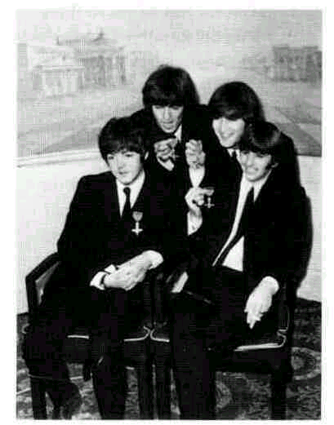
The Beetles with their MBEs

8o 7 The monarchy

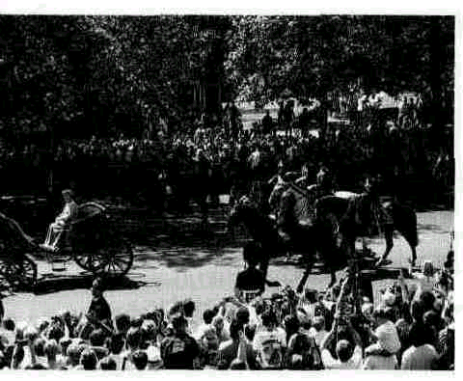
The Queen, attracting foreign tourists
> The economic argument
Every tourist brochure for Britain in every country in the world gives great prominence to the monarchy. It is impossible to estimate exactly how much the British royal family and the events and buildings associated with the monarchy help the tourist industry, or exactly how much money they help to bring into the country. But most people working in tourism think it is an awful lot!
> Edward and Mrs Simpson
For the last two centuries the public have wanted their monarch to have high moral standards. In 1936 Edward VIII, the uncle of the present Queen, was forced to abdicate (give up the throne). This happened because he wanted to marry a woman who had divorced two husbands. (On top of that, she was not even a British aristocrat -she was an American!) The government and the major churches in the country insisted that Edward could not marry her and remain king. He chose to marry her. The couple then went to live abroad. In spite of the constitutional crisis that he caused, the Duke of Windsor (as Edward later became) and his wife were popular celebrities in Britain all their lives, and the king's abdication has gone down in popular history as an example of the power of love.
The value of the monarchy
However, all these advantages are hypothetical. It cannot be proved that only a monarch can provide them. Other modern democracies manage perfectly well without one. The British monarchy is probably more important to the economy of the country (o The economic argument) than it is to the system of government. Apart from this, the monarchy is very popular with the majority of the British people. The monarchy gives British people a symbol of continuity, and a harmless outlet for the expression of national pride. Even in very hard times it has never seemed likely that Britain would turn to a dictator to get it out of its troubles. The grandeur of its monarchy may have been one of the reasons for this.
Occasions such as the state opening of Parliament, the Queen's official birthday, royal weddings, and ceremonial events such as the changing of the guard make up for the lack of colour and ceremony in most people's daily lives. (There is no tradition of local parades as there is in the USA, and very few traditional local festivals survive as they do in other European countries.) In addition the glamorous lives of'the royals' provide a source of entertainment that often takes on the characteristics of a television soap opera. When, in 1992, it became known that Prince Charles and his wife Princess Diana were separating, even the more 'serious' newspapers discussed a lot more than the possible political implications. The Sunday Times published a 'five-page royal separation special'.
The future of the monarchy
For the last 250 years, the British monarchy as an institution has only rarely been a burning political issue. Only occasionally has there been debate about the existence of the monarchy itself. Few people in Britain could be described as either 'monarchists' or 'anti-monarchists', in the sense in which these terms are often used in other countries. Most people are either vaguely in favour or they just don't care one way or the other. There is, however, a great deal of debate about what kind of monarchy Britain should have. During the last two decades of the twentieth century, there has been a general cooling of enthusiasm. The Queen herself remains popular. But the various marital problems in her family have lowered the prestige of royalty in many people's eyes. The problem is that, since Queen Victoria's reign, the public have been encouraged to look up to the royal family as a model of Christian family life.
The change in attitude can be seen by comparing Queen Elizabeth's 25th anniversary as Queen with her 40th anniversary. In 1977, there were neighbourhood street parties throughout the country, most of them spontaneously and voluntarily organized. But in 1992, nothing like this took place. On 20 November 1992, a fire damaged one of the Queen's favourite homes to the value of £60 million. There were

expressions of public sympathy for the Queen. But when the government announced that public money was going to pay for the repairs, the sympathy quickly turned to anger. The Queen had recently been reported to be the richest woman in the world, so people didn't see why she shouldn't pay for them herself.
It is, in fact, on the subject of money that 'anti-royalist' opinions are most often expressed. In the early nineties even some Conservative MPs, traditionally strong supporters of the monarchy, started protesting at how much the royal family was costing the country. "or the whole of her long reign Elizabeth II had been exempt from ixation. But, as a response to the change in attitude, the Queen recided that she would start paying taxes on her private income. In iddition, Civil List payments to some members of the royal family where stopped. (The Civil List is the money which the Queen and some other relatives get from Parliament each year so that they can carry out their public duties.)
For most people, the most notable event marking Queen Elizabeth's 40th anniversary was a television programme about a year in her life which showed revealing details of her private family life. In the following year parts of Buckingham Palace were, for the first ome, opened for public visits (to raise money to help pay for the repairs to Windsor Castle). These events are perhaps an indication of the future royal style — a little less grand, a little less distant.
The future of the monarchy 81
> One's bum year
The Sun is Britain's most popular daily newspaper (see chapter 18). This was its front page headline after the Queen had spoken of 1992 as an onnus horribilis (Latin for 'a horrible year'). As well as the separation of Charles and Diana, 1992 had included the fire at Windsor Castle and the news that Australia was intending to break its ties with the
'old country' and become a republic.
The headline uses the similarity between 'annus' and 'anus' to make a pun of 'bum' (which, in colloquial British English, can mean both
'anus' and 'horrible'). It also mimics the supposed frequent use by the Queen of the pronoun 'one' to mean
'I/me'. The headline thus mixes the very formal-sounding 'one' with the very colloquial 'bum'. It is impossible to imagine that such a disrespectful (and unsympathetic) headline could have appeared in the 1950s or1960s.

QUESTIONS
1 Why does the British Prime Minister continue 3 Would you advise the British to get rid of their
to'advise'and'request'the Queen, when monarchy?
everybody knows that he or she is really relling
her what to do? 4 Do you have a monarch in your country, or
someone who fulfils a similar role? If you do,
2 The attitude of the British people towards their how does their position compare with that of royal family has changed over the last quarter the British monarch? If you don't, do you think of the twentieth century. In what way has it your country would benefit from having a changed, and what demonstrates that there has figurehead who could perform the functions of been a change? Why do you think this has a monarch? happened?

SUGGESTIONS
* The Queen and I by Sue Townsend (Mandarin) includes humorous
characterizations of the main members of the royal family.
* Books about the monarchy abound. Among them are: The Prince of Wales: A Biography by Jonathan Dimbleby (Little, Brown and Company), The Queen by Kenneth Harris (Orion), Elizabeth R: The Role of Ac Monarchy Today by Antony Jay (BBC Books), Diana, Her True Story and Diana, Her New Life, both by Andrew Morton (Michael O'Mara Books Limited).

